**“What is AWS?”**

Amazon Web Services (AWS) is the world’s most comprehensive and broadly adopted cloud platform, offering over 200 fully featured services from data centers globally. Millions of customers—including the fastest-growing startups, largest enterprises, and leading government agencies—are using AWS to lower costs, become more agile, and innovate faster.

**“AWS Service”**

1. Compute
2. Containers
3. Storage
4. Database
5. Security, Identity, & Compliance
6. Cryptography & PKI
7. Machine Learning
8. Management and Governance
9. Developer Tools
10. Migration &Transfer
11. Networking & Content Delivery
12. Media Services
13. Internet of Things (IoT)
14. Front-End Web & Mobile
15. End User Computing
16. Analytics
17. Application Integration
18. Business Applications
19. Customer Enabled Services
20. SDKs &Toolkits

**“AWS Pricing Models”**

AWS offers you a pay-as-you-go approach for pricing for over 200 cloud services. With AWS you pay only for the individual services you need, for as long as you use them, and without requiring long-term contracts or complex licensing. AWS pricing is similar to how you pay for utilities like water and electricity. You only pay for the services you consume, and once you stop using them, there are no additional costs or termination fees.

### Pay-as-you-go

Pay-as-you-go allows you to easily adapt to changing business needs without overcommitting budgets and improving your responsiveness to changes. With a pay-as-you-go model, you can adapt your business depending on need and not on forecasts, reducing the risk of overprovisioning or missing capacity.

### Save when you commit

For AWS Compute and AWS Machine Learning, Savings Plans offer savings over On-Demand in exchange for a commitment to use a specific amount (measured in $/hour) of an AWS service or a category of services, for a one- or three-year period.

### Pay less by using more

With AWS, you can get volume-based discounts and realize important savings as your usage increases. For services such as S3, pricing is tiered, meaning the more you use, the less you pay per GB. AWS also gives you options to acquire services that help you address your business needs.

### **“AWS Pricing Calculator”**

Whether you are running a single instance or dozens of individual services, you can estimate your monthly bill using the AWS Pricing Calculator. The calculator allows you to estimate individual or multiple prices and use templates to appraise complete solutions.

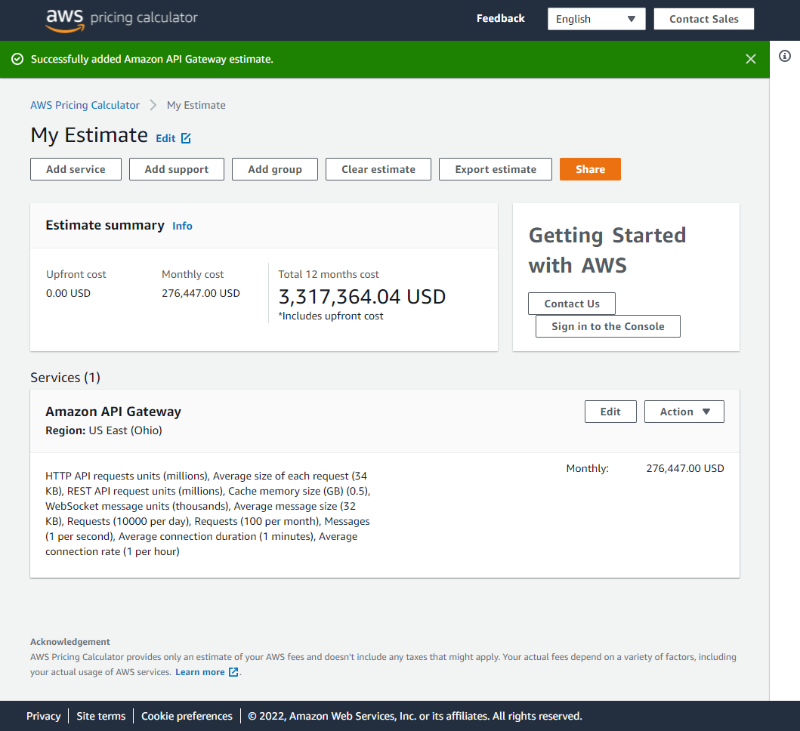

**AWS EC2:**

Amazon Elastic Compute Cloud (Amazon EC2) provides scalable computing capacity in the Amazon Web Services (AWS) Cloud. Using Amazon EC2 eliminates your need to invest in hardware up front, so you can develop and deploy applications faster. You can use Amazon EC2 to launch as many or as few virtual servers as you need, configure security and networking, and manage storage. Amazon EC2 enables you to scale up or down to handle changes in requirements or spikes in popularity, reducing your need to forecast traffic.

**AWS Lambda:**

With AWS Lambda, you can run code without provisioning or managing servers. You pay only for the compute time that you consume—there's no charge when your code isn't running. You can run code for virtually any type of application or backend service—all with zero administration. Just upload your code and Lambda takes care of everything required to run and scale your code with high availability. You can set up your code to automatically trigger from other AWS services or call it directly from any web or mobile app.

**Amazon S3:**

Amazon Simple Storage Service (Amazon S3) is an object storage service that offers industry-leading scalability, data availability, security, and performance. Customers of all sizes and industries can use Amazon S3 to store and protect any amount of data for a range of use cases, such as data lakes, websites, mobile applications, backup and restore, archive, enterprise applications, IoT devices, and big data analytics. Amazon S3 provides management features so that you can optimize, organize, and configure access to your data to meet your specific business, organizational, and compliance requirements.

**AWS Backup:**

AWS Backup is a fully-managed service that makes it easy to centralize and automate data protection across AWS services, in the cloud, and on premises. Using this service, you can configure backup policies and monitor activity for your AWS resources in one place. It allows you to automate and consolidate backup tasks that were previously performed service-by-service, and removes the need to create custom scripts and manual processes. With a few clicks in the AWS Backup console, you can automate your data protection policies and schedules.

**Amazon RDS:**

Amazon Relational Database Service (Amazon RDS) is a web service that makes it easier to set up, operate, and scale a relational database in the AWS Cloud. It provides cost-efficient, resizable capacity for an industry-standard relational database and manages common database administration tasks.

**IAM:**

AWS Identity and Access Management (IAM) is a web service that helps you securely control access to AWS resources. You use IAM to control who is authenticated (signed in) and authorized (has permissions) to use resources.

When you first create an AWS account, you begin with a single sign-in identity that has complete access to all AWS services and resources in the account. This identity is called the AWS account *root user* and is accessed by signing in with the email address and password that you used to create the account. We strongly recommend that you do not use the root user for your everyday tasks, even the administrative ones. Instead, adhere to the [best practice of using the root user only to create your first IAM user](https://docs.aws.amazon.com/IAM/latest/UserGuide/best-practices.html#create-iam-users). Then securely lock away the root user credentials and use them to perform only a few account and service management tasks.

**AWS CodeStar:**

AWS CodeStar is a cloud-based service for creating, managing, and working with software development projects on AWS. You can quickly develop, build, and deploy applications on AWS with an AWS CodeStar project. An AWS CodeStar project creates and integrates AWS services for your project development toolchain. Depending on your choice of AWS CodeStar project template, that toolchain might include source control, build, deployment, virtual servers or serverless resources, and more. AWS CodeStar also manages the permissions required for project users (called team members). By adding users as team members to an AWS CodeStar project, project owners can quickly and simply grant each team member role-appropriate access to a project and its resources.

**Amazon VPC:**

Amazon Virtual Private Cloud (Amazon VPC) enables you to launch AWS resources into a virtual network that you've defined. This virtual network closely resembles a traditional network that you'd operate in your own data center, with the benefits of using the scalable infrastructure of AWS.

**Amazon SNS:**

Amazon Simple Notification Service (Amazon SNS) is a managed service that provides message delivery from publishers to subscribers (also known as *producers* and *consumers*). Publishers communicate asynchronously with subscribers by sending messages to a *topic*, which is a logical access point and communication channel. Clients can subscribe to the SNS topic and receive published messages using a supported endpoint type, such as Amazon Kinesis Data Firehose, Amazon SQS, AWS Lambda, HTTP, email, mobile push notifications, and mobile text messages (SMS).

**Amazon Route 53:**

Amazon Route 53 is a highly available and scalable Domain Name System (DNS) web service. You can use Route 53 to perform three main functions in any combination: domain registration, DNS routing, and health checking.

**Amazon CloudFront:**

Amazon CloudFront is a web service that speeds up distribution of your static and dynamic web content, such as .html, .css, .js, and image files, to your users. CloudFront delivers your content through a worldwide network of data centers called edge locations. When a user requests content that you're serving with CloudFront, the request is routed to the edge location that provides the lowest latency (time delay), so that content is delivered with the best possible performance.

**Amazon ECS:**

Amazon Elastic Container Service (Amazon ECS) is a highly scalable and fast container management service. You can use it to run, stop, and manage containers on a cluster. With Amazon ECS, your containers are defined in a task definition that you use to run individual tasks or tasks within a service. In this context, a service is a configuration that you can use to run and maintain a specified number of tasks simultaneously in a cluster. You can run your tasks and services on a serverless infrastructure that's managed by AWS Fargate. Alternatively, for more control over your infrastructure, you can run your tasks and services on a cluster of Amazon EC2 instances that you manage.

**AWS Serverless Application Repository:**

The AWS Serverless Application Repository makes it easy for developers and enterprises to quickly find, deploy, and publish serverless applications in the AWS Cloud. You can easily publish applications, sharing them publicly with the community at large, or privately within your team or across your organization. To publish a serverless application (or app), you can use the AWS Management Console, the AWS SAM command line interface (AWS SAM CLI), or AWS SDKs to upload your code. Along with your code, you upload a simple manifest file, also known as an AWS Serverless Application Model (AWS SAM) template.

The AWS Serverless Application Repository is deeply integrated with the AWS Lambda console. This integration means that developers of all levels can get started with serverless computing without needing to learn anything new. You can use category keywords to browse for applications such as web and mobile backends, data processing applications, or chatbots.

**AWS CloudFormation:**

AWS CloudFormation is a service that helps you model and set up your AWS resources so that you can spend less time managing those resources and more time focusing on your applications that run in AWS. You create a template that describes all the AWS resources that you want (like Amazon EC2 instances or Amazon RDS DB instances), and CloudFormation takes care of provisioning and configuring those resources for you. You don't need to individually create and configure AWS resources and figure out what's dependent on what; CloudFormation handles that.

**Amazon EFS:**

Amazon Elastic File System (Amazon EFS) provides a simple, serverless, set-and-forget elastic file system for use with AWS Cloud services and on-premises resources. It is built to scale on demand to petabytes without disrupting applications, growing and shrinking automatically as you add and remove files, eliminating the need to provision and manage capacity to accommodate growth. Amazon EFS has a simple web services interface that allows you to create and configure file systems quickly and easily. The service manages all the file storage infrastructure for you, meaning that you can avoid the complexity of deploying, patching, and maintaining complex file system configurations.

Amazon EFS supports the Network File System version 4 (NFSv4.1 and NFSv4.0) protocol, so the applications and tools that you use today work seamlessly with Amazon EFS. Multiple compute instances, including Amazon EC2, Amazon ECS, and AWS Lambda, can access an Amazon EFS file system at the same time, providing a common data source for workloads and applications running on more than one compute instance or server.

# **Amazon EC2 Auto Scaling:**

Amazon EC2 Auto Scaling helps you ensure that you have the correct number of Amazon EC2 instances available to handle the load for your application. You create collections of EC2 instances, called *Auto Scaling groups*. You can specify the minimum number of instances in each Auto Scaling group, and Amazon EC2 Auto Scaling ensures that your group never goes below this size.

You can specify the maximum number of instances in each Auto Scaling group, and Amazon EC2 Auto Scaling ensures that your group never goes above this size. If you specify the desired capacity, either when you create the group or at any time thereafter, Amazon EC2 Auto Scaling ensures that your group has this many instances. If you specify scaling policies, then Amazon EC2 Auto Scaling can launch or terminate instances as demand on your application increases or decreases.

# **Target tracking scaling policies for Application Auto Scaling:**

With target tracking scaling policies, you choose a scaling metric and set a target value. Application Auto Scaling creates and manages the CloudWatch alarms that trigger the scaling policy and calculates the scaling adjustment based on the metric and the target value. The scaling policy adds or removes capacity as required to keep the metric at, or close to, the specified target value. In addition to keeping the metric close to the target value, a target tracking scaling policy also adjusts to changes in the metric due to a changing load pattern.